Albert Waterman
CS499 enhancement two
The artifact I selected for the algorithms and data structures category is my Task Service project from CS 320. I created the original project earlier in the Computer Science program using Java and JUnit testing. The original project included a Task class, TaskService class, TaskTest class, and TaskServiceTest class. The Task class stored a task ID, name, and description. It also validated the length and null requirements for each value. The task ID could not be changed after the task was created, but the name and description could be updated. The original TaskService used a HashMap to store tasks by their task IDs. It allowed users to add, delete, retrieve, and update tasks. The original application was great for basic task management, but it did not determine which task should be completed first or handle dependencies between tasks.
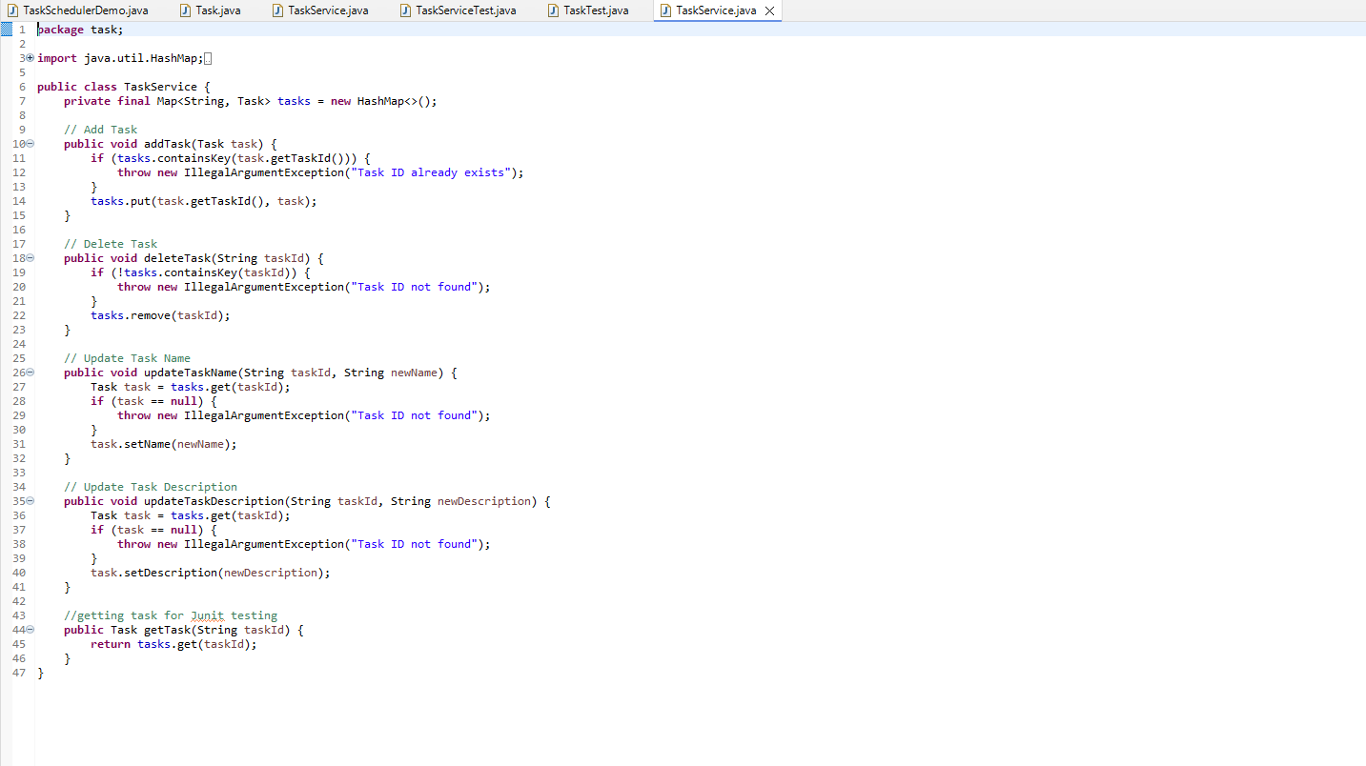
I selected this artifact because it gave me a good starting point for showing my growth in algorithms and data structures. The original application already used a HashMap, object-oriented programming, input validation, and JUnit tests. It was still mainly a basic create, read, update, and delete application. I wanted to improve it into something that could solve more realistic scheduling issues. My original enhancement plan was to keep the HashMap for task lookup while adding task priorities, due dates, a dependency graph, a PriorityQueue, topological sorting, and cycle detection. I also planned to add more JUnit tests to verify the scheduling system.
The first improvement was adding a priority and due date to the Task class. Priority values range from 1 through 5, with 1 being the highest priority. I also kept the original three-value constructor so the original tests and code would still work. When the original constructor is used, the task receives a default priority of 3 and a due date placed far into the future. The priority and due-date fields allow the scheduler to compare tasks. When multiple tasks are available, the task with the lower priority number is selected first. If two available tasks have the same priority, the task with the earlier due date is selected. The task ID is used as the final comparison when the priority and due date are the same. The second improvement was adding a dependency graph. A dependency means that one task must be completed before another task can start. For example, a repair task may depend on inspecting the equipment, ordering parts, gathering tools, and backing up system settings. I represented the dependency graph using a HashMap that connects each task ID to a Set of required task IDs. The set prevents the same dependency from being added more than once. This allows the application to store multiple requirements for each task. I planned this very similar to how my job operates currently and am very impressed with how it turned out. The main algorithmic improvement was the buildTaskSchedule() method. This method uses the topological sort algorithm. The algorithm creates a valid order by counting how many unfinished dependencies each task has.
One important part of the enhancement is that dependencies come before priority. A priority 1 task cannot be scheduled if it still depends on another task. This keeps the schedule valid even when a task has a higher priority than one of the tasks it depends on. I used four tasks in the demo program. Ordering parts, inspecting the system, repairing the system, and verifying the repair. The repair task depends on both the parts and inspection tasks, so it cannot begin until both are completed. The verification task depends on the repair task, so it must be completed last. This shows how the application can organize connected tasks while still considering priority and due dates. The scheduler also detects dependency cycles. A cycle happens when tasks depend on each other in a way that makes it impossible for the schedule to continue. For example, the repair task cannot depend on the verification task while the verification task also depends on the repair task. After the scheduling process finishes, the program compares the number of scheduled tasks with the total number of tasks. If the numbers do not match, the program throws an exception instead of returning an invalid schedule.
This enhancement also demonstrates how I used several data structures together. The HashMap stores each task by its ID and provides an average lookup time of O(1). Sets store the task dependencies and prevent the same dependency from being added more than once. Another map keeps track of the number of unfinished dependencies for each task. The PriorityQueue chooses the best available task, and an ArrayList stores the final task schedule. The topological sort goes through every task and dependency relationship. The estimated time complexity is O(V log V + E), where V represents the number of tasks and E represents the number of dependency connections. The graph and supporting collections use O(V + E) space. This requires more memory and processing than the original application, but the trade-off is that the program can now create a valid schedule that follows priorities, due dates, and dependency requirements.

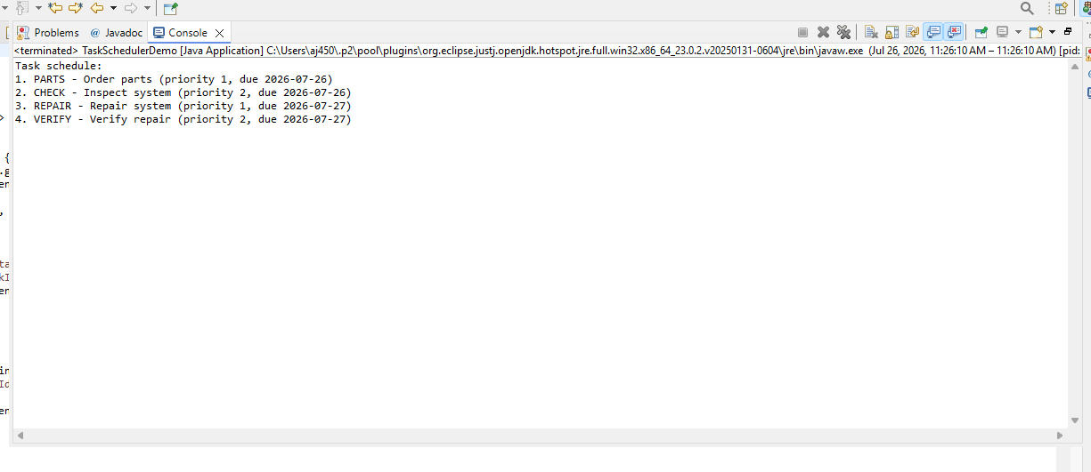
The main outcome it connects to is Course Outcome 3 because I used algorithms and data structures to solve the scheduling problem. I also had to think about the trade-offs involved with the different choices I made. I used different data structures because each one had a different purpose. The HashMap makes it easy to find a task by its ID. The dependency graph shows which tasks have to be completed before another task can begin. The incoming dependency map keeps track of how many requirements each task still has. The PriorityQueue then chooses which available task should come next based on priority and due date.
I also compared using a normal queue with using a priority queue. A normal queue could still create a valid order, but it would not consider which task is more important or due sooner. The priority queue takes a little more processing, but it creates a better schedule. The four-task example shows this clearly. The parts and inspection tasks have to be completed before the repair task can begin. The verification task has to wait until the repair is finished. Even though the repair task has a high priority, the program will not schedule it before the tasks it depends on.
This enhancement also supports Course Outcome 4 because I used Java, JUnit, Eclipse, object-oriented programming, and Java collection classes to create a working solution. The new version has more value than the original because it can now handle priorities, due dates, dependencies, and invalid schedules. Course Outcome 2 is also covered through my code comments, test names, screenshots, code review, and this narrative. I explained what I changed and why I made those choices.
One of the main things I learned was that priority alone does not create a valid schedule. I thought all the tasks could just go into one priority queue and be completed based on importance. The problem with that is a high-priority task could be scheduled before the work it depends on. I had to separate a task being important from a task being ready. The dependency graph decides when a task is ready. The priority queue only decides which ready task should come next. The four-task example helped me understand this idea. The parts and inspection tasks are ready first because they do not depend on anything else. The repair task only becomes ready after both of those tasks are completed. The verification task only becomes ready after the repair is done.
One challenge was understanding the direction of the dependency graph. When a task is completed, the program has to find the tasks that were waiting on it and lower their dependency counts. For example, finishing the parts task lowers one dependency for the repair task. Finishing the inspection task lowers the other dependency, which then allows the repair task to be added to the priority queue. Deleting tasks also took more thought than it did in the original application. Removing a task from the main HashMap was not enough because the task ID could still be stored as a dependency for another task. I updated the delete method so it removes the task from the main map, removes its dependency information, and removes its ID from the other dependency sets.
Another challenge was keeping the original three-argument constructor while adding the new constructor with priority and due date. Keeping both constructors allowed the original code and tests to keep working while also supporting the new scheduling features. This showed me how to improve an existing program without breaking everything that already worked. Testing was also important during this enhancement. I kept the original tests for creating, updating, deleting, and validating tasks. I added more tests for priority order, due-date order, dependencies, missing tasks, self-dependencies, deleting dependency references, and cycle detection.
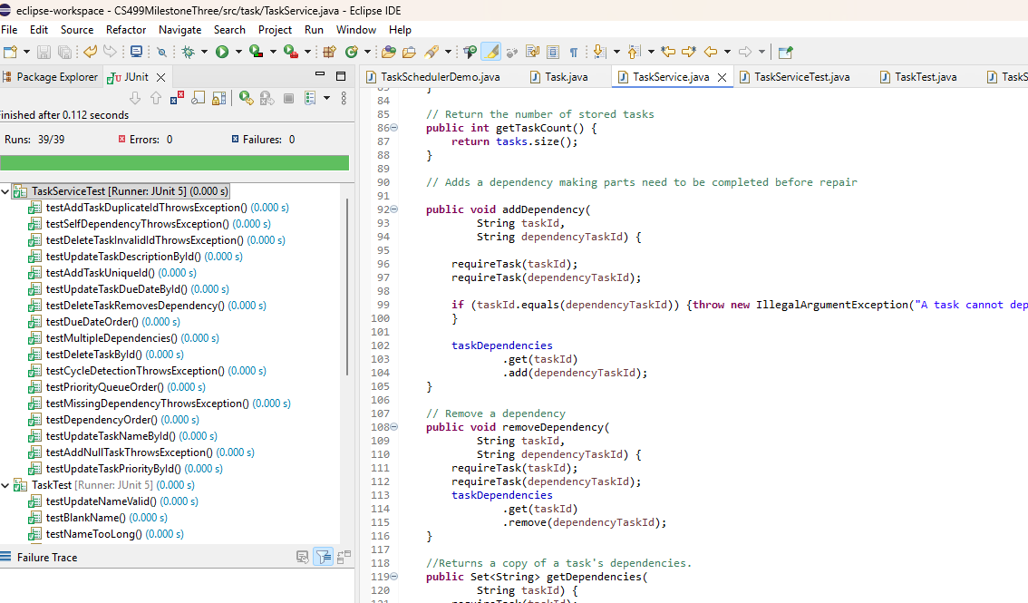
I ran all of the tests in Eclipse, and all 39 tests passed with zero errors and zero failures. This helped confirm that the new scheduling features worked and that the original features still worked too.
This enhancement helped me understand how several data structures can work together to solve one problem. The original application mainly used a HashMap for basic task storage. The enhanced version uses a HashMap, sets, a dependency graph, incoming dependency counts, a priority queue, and an ArrayList. Even though the demonstration only uses four tasks, it still clearly shows how the scheduler works. The parts and inspection tasks must be completed before the repair, and the repair must be completed before verification.
References:
Lexicographically smallest topological ordering - geeksforgeeks. (n.d). https://www.geeksforgeeks.org/dsa/lexicographically-smallest-topological-ordering/

Test classes and methods :: Junit user guide. (n.d.-h). https://docs.junit.org/6.1.2/writing-tests/test-classes-and-methods.html

Priorityqueue (Java SE 17 & JDK 17). (n.d). https://docs.oracle.com/en/java/javase/17/docs/api/java.base/java/util/PriorityQueue.html

HashMap (Java SE 21 & JDK 21). (n.d). https://docs.oracle.com/en/java/javase/21/docs/api/java.base/java/util/HashMap.html

